**Lab 01**

**[CLO-01, PLO-01, P3(Guided Response), Rubric (Hardware Configurations)]**

**Introduction to Basic Electrical Wiring of a House, Safety and Earthing Concepts**

Alternating Current (AC) and Direct Current (DC) are two different forms of electrical current used in various applications. Here are five key differences between them in terms of their characteristics, uses, and sources, along with practical examples:

|  |  |
| --- | --- |
| **AC (Alternating Current)** | **DC (Direct Current)** |
| **Direction of Flow:** AC constantly changes direction, oscillating back and forth in a sinusoidal manner. The current flows in one direction and then reverses, creating a continuous cycle.  Alternating Current (AC) vs. Direct Current (DC) - Codrey Electronics | **Direction of Flow:** DC maintains a constant flow of electrons in one direction. The current does not change direction periodically.  18 Difference between AC and DC Current [Alternating vs Direct] |
| **Voltage Level:** AC voltage levels can be easily transformed using transformers, making it suitable for long-distance transmission at high voltages and efficient distribution to homes and businesses at lower voltages. | **Voltage Level:** DC voltage levels are typically fixed and not as easily transformed as AC. Voltage drop over long distances can be significant, making DC less suitable for long-distance transmission. |
| Electrical power system performing generation, transmission, and... |  Download Scientific Diagram**Reduced Energy Losses:** AC transmission lines experience lower energy losses due to a phenomenon called skin effect. In AC, the current periodically changes direction, which causes the current to spread across the entire cross-section of the conductor, reducing resistance-related losses. In contrast, DC flows continuously in one direction, causing more concentrated current flow at the conductor's surface, which leads to higher resistive losses. This effect is especially significant in high-voltage, long-distance transmission lines. | |
| **Use:** AC is predominantly used for household electrical appliances, power transmission over long distances, and in most industrial and commercial applications. | **Use:** DC is commonly used in electronic devices, batteries, electric vehicles (EVs), and certain specialized applications like computer chips and solar panels. |
| **Source:** AC is generated by rotating machinery such as generators and alternators. Most power plants, including coal, gas, nuclear, and renewable energy facilities, generate AC electricity. | **Source:** DC can be generated through batteries, photovoltaic (solar) cells, fuel cells, and rectifiers. It is also produced by converting AC to DC using devices like rectifiers or power supplies. |
| **Practical Example:** The power supplied to homes and businesses through electrical outlets is typically AC. When you plug in devices like lamps, refrigerators, or televisions, they operate on AC power. | **Practical Example:** Battery-operated devices, such as smartphones and laptops, rely on DC power. Electric vehicles, like Teslas, use DC power from their batteries to drive electric motors. |
| **In summary**, AC and DC differ in terms of the direction of current flow, voltage levels, primary use cases, sources of generation, and practical applications. AC is suitable for long-distance power transmission and most household appliances, while DC is prevalent in electronics, batteries, and specialized applications like electric vehicles and renewable energy systems. | |

**Basic Principle:**

1. **Circuit Basics**:
   * **Circuit**: A circuit is a closed loop through which electricity flows. It typically consists of a power source (such as a breaker or fuse), conductors (wires), and electrical devices (lights, outlets, switches).
   * **Series vs. Parallel Circuits**: In residential wiring, circuits are typically wired in parallel. This means that devices are connected across the circuit in separate branches, allowing one device to operate independently of the others. In a series circuit, devices are connected end-to-end, and if one fails, the entire circuit is interrupted.
2. **Electrical Service Entrance**:
   * **Service Panel**: The electrical service panel, also known as the circuit breaker panel or fuse box, is where electricity enters the house from the utility. It contains circuit breakers or fuses that protect individual circuits from overloads and faults.
   * **Main Disconnect**: The main disconnect switch or breaker in the service panel allows for the complete shutdown of electrical power to the entire house for maintenance or emergencies.
3. **Wiring Materials**:
   * **Conductors:** Wires made of copper or aluminum are used to carry electrical current. Different sizes (gauges) of wires are used for different applications, with thicker wires carrying more current.
   * **Insulation**: Wires are insulated to prevent electrical shock and short circuits. Common insulation types include PVC (Polyvinyl Chloride) and THHN (Thermoplastic High Heat-resistant Nylon).
4. **Outlets and Switches:**
   * **Outlets (Receptacles):** These are where electrical devices are plugged in. Residential outlets include standard 120-volt outlets and higher voltage outlets for appliances like ovens and dryers.
   * **Switches**: Switches control the flow of electricity to lights and other fixtures. They can be single-pole (controlling one fixture) or three-way/two-way (controlling a fixture from multiple locations).
5. **Circuit Protection**:
   * **Circuit Breakers**: Circuit breakers are designed to trip and disconnect the circuit when the current exceeds a safe level, preventing overheating and fires. They can be reset after tripping.
   * **Fuses**: Fuses serve a similar purpose to circuit breakers but must be replaced when they blow (melt). They are less common in modern residential wiring.
6. **Grounding and Earthing:**
   * **Grounding**: Grounding is a safety measure that connects electrical systems to the earth (ground) to prevent electrical shock and reduce the risk of fires. It provides a path for fault currents to safely dissipate.
   * **Grounding Electrode System**: This includes grounding rods driven into the ground and the grounding conductor that connects the electrical system to these rods.
7. **Electrical Codes and Regulations**:
   * Residential electrical wiring must adhere to local electrical codes and regulations. These codes ensure that wiring is safe and up to current standards.
8. **Safety Precautions**:
   * Safety is paramount in residential electrical work. Always turn off power at the source before working on electrical systems, use appropriate personal protective equipment (PPE), and follow safety guidelines to prevent electrical shocks and fires.
9. **Load Calculation**:
   * Proper load calculation ensures that the electrical system can handle the connected devices without overloading. It involves determining the electrical demand of appliances and fixtures in a home.

Understanding these basic principles of residential electrical wiring is essential for safely and effectively working with electrical systems in homes. Always consult a qualified electrician or follow local electrical codes when performing electrical work.

**Safety precautions when working with electricity Top of Form**

1. **Turn Off the Power:**
   * Before starting any electrical work, turn off the power at the circuit breaker or fuse box. Confirm that the circuit is de-energized by using a voltage tester or multimeter.
2. **Lockout/Tagout Procedures:**
   * In industrial or commercial settings, follow lockout/tagout procedures to ensure that equipment is isolated from energy sources and cannot be accidentally turned on while maintenance is in progress.
3. **Use Proper Personal Protective Equipment (PPE):**
   * Wear appropriate PPE, including safety goggles, insulated gloves, and flame-resistant clothing, when necessary, to protect yourself from electrical hazards.
4. **Work in a Dry Environment:**
   * Ensure that the work area is dry and free of water or moisture. Water and electricity do not mix and can cause electrical shock.
5. **Inspect Tools and Equipment:**
   * Regularly inspect all tools and equipment for signs of wear, damage, or exposed wiring. Damaged tools should be repaired or replaced immediately.
6. **Use Insulated Tools:**
   * When working on electrical components, use tools with insulated handles to prevent accidental contact with live wires.
7. **Avoid Overloading Circuits:**
   * Do not overload electrical circuits with too many devices or appliances. Follow the manufacturer's recommendations for the maximum load capacity of outlets and circuits.
8. **Properly Ground Yourself:**
   * If working on live electrical equipment, use an appropriate grounding strap to prevent static discharge and electrostatic buildup.
9. **Keep a Safe Distance:**
   * Maintain a safe distance from live electrical components, especially when working with high-voltage systems.
10. **Test for Live Wires:**
    * Always test wires and equipment to ensure they are de-energized before touching them. Use a voltage tester or multimeter to confirm that there is no electrical voltage present.
11. **One Hand Rule:**
    * When working on live circuits, use the "one hand rule." Keep one hand in your pocket or behind your back to minimize the risk of forming a complete circuit.
12. **Use Ground Fault Circuit Interrupters (GFCIs):**
    * Install GFCIs in areas where electrical equipment might come into contact with water, such as kitchens, bathrooms, and outdoor outlets. GFCIs can quickly disconnect power in case of a ground fault.
13. **Secure Loose Wires:**
    * Make sure all wires are properly secured and not hanging loose. Loose wires can cause shorts or electrical arcing.
14. **Label Circuit Breakers and Fuses:**
    * Ensure that circuit breakers and fuses are correctly labeled to make it easy to identify and turn off power to specific circuits.
15. **Avoid DIY if Inexperienced:**
    * If you're not trained or experienced in electrical work, do not attempt complicated electrical tasks. Hire a licensed electrician for complex installations and repairs.
16. **Emergency Response:**
    * Know the location of fire extinguishers, first-aid kits, and emergency exits in your work area. Be prepared to respond to electrical fires or accidents.
17. **Learn CPR and First Aid:**
    * Knowing CPR and first aid can be valuable in case of electrical accidents. Consider taking a course to learn these life-saving skills.

Always prioritize safety when working with electricity, and if you are uncertain about any aspect of the job, consult a qualified electrician or professional with the necessary expertise. Electrical safety should never be compromised.

**Top of Form**

**Lab Task 01: Try** to describe the answers of following questions in your own wordings by reading the material provided in manual about Lab 01.

**[CLO-01, PLO-01, P3(Guided Response), Rubric (Hardware Configurations)]**

**Rubric:**

|  |  |  |  |  |
| --- | --- | --- | --- | --- |
| **Marks** | **1** | **2** | **3** | **4** |
| **Hardware Configurations** | The hardware configuration is not as per guidelines and requirements are not met | Some section of hardware configuration is correct | Most section of hardware configuration is correct and understands it well | The hardware configuration is properly done, and have good understanding about it |

1. What are the key differences between Alternating Current (AC) and Direct Current (DC) in terms of their voltage levels, direction of flow, and practical applications?
2. Why is AC preferred for long-distance power transmission, and how does it mitigate energy losses compared to DC?
3. What are some practical examples of devices and systems that operate on AC power, and what about those that rely on DC power?
4. Explain the concept of grounding and earthing in electrical systems and why it is crucial for safety.
5. What safety precautions should be followed when working with electricity, and why is it essential to turn off power at the source before conducting electrical work?

**Lab Task 02: Practice** thebasic house wiring as provided in the example below and create a design illustrating how this wiring can be implemented.

**[CLO-01, PLO-01, P3(Guided Response), Rubric (Hardware Configurations)]**

**Rubric:**

|  |  |  |  |  |
| --- | --- | --- | --- | --- |
| **Marks** | **1** | **2** | **3** | **4** |
| **Hardware Configurations** | The hardware configuration is not as per guidelines and requirements are not met | Some section of hardware configuration is correct | Most section of hardware configuration is correct and understands it well | The hardware configuration is properly done, and have good understanding about it |

Top of Form

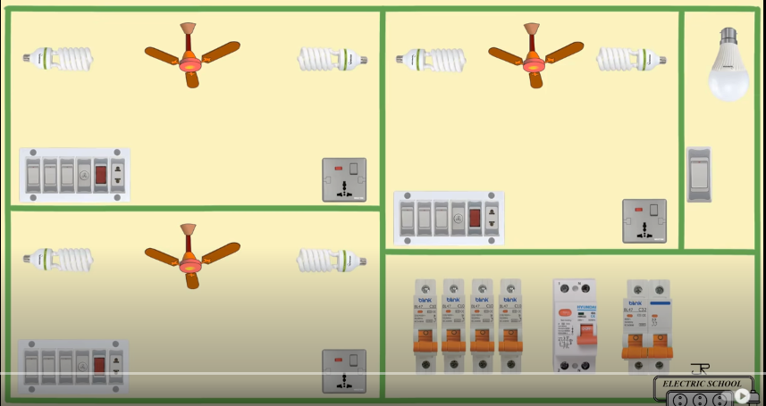

**Lab Report Rubric:** *must be submitted in next lab***.**

|  |  |  |  |  |
| --- | --- | --- | --- | --- |
| **Marks** | **1** | **2** | **3** | **4** |
| **Lab Report** | The lab report does not follow the guidelines for formatting. | Presents some sections of the lab in the correct order. Three or more sections are not in the correct order; missing heading or title; | Presents most sections of the lab in the correct order, one or two sections may not be in the correct order; heading or title missing or not complete; | Presents all the sections of the lab in the correct order with correct formatting: includes correct heading, section headings and title of lab; |